**Solution**

**Q 1. Change the permission set of /work/readme.txt so that only the user (owner) can read,write and execute it. Use absolute mode.**

Set the permission. 7 for user, 0 for group and 0 for others.

**Command:** chmod 700 /work/readme.txt

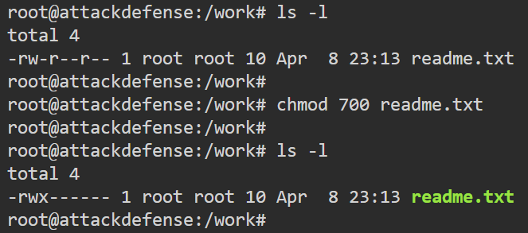

**Q 2. Change the permission set of /work/readme.txt so that any user can read it, the group can read/write to it and the user (owner) can read/write/execute it. Use absolute mode.**

Set the permission. 7 for user, 6 for group and 4 for others.

**Command:** chmod 764 /work/readme.txt

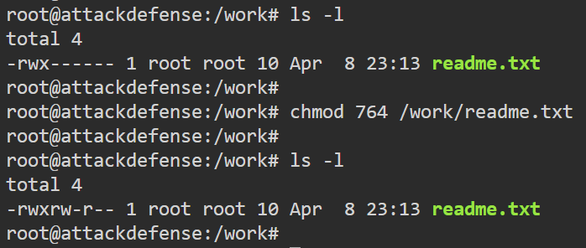

**Q 3. Change the permission set of /bin/bash so that only the user (owner) can read/write/ execute, group and any user can execute it. However, whenever anyone executes it, it should run with the privileges of the owner user. Use absolute mode.**

Set the permission. 7 for user, 1 for group and 1 for others. To make sure it only executes with owner’s user’s privileges, set setuid bit, which means setting value 4.

**Command:** chmod 4711 /bin/bash

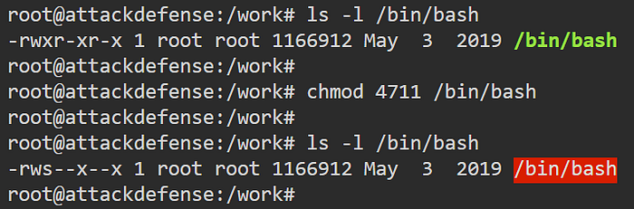

**Q 4. Change the permission set of /work/readme.txt so that only the user (owner) can read, write, and execute it. Use symbolic mode.**

Set the permission. Depending on the current permissions, the user may have to nullify some of the permissions.

**Command:**   
chmod u+rwx /work/readme.txt

chmod g-rw /work/readme.txt

chmod o-r /work/readme.txt

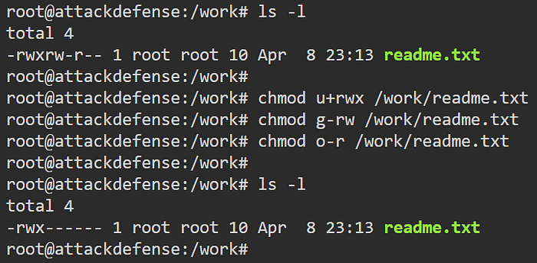

**Q 5. Change the permission set of /work/readme.txt so that any user can read it, the group can read/write to it and the user (owner) can read/write/execute it. Use symbolic mode.**

Set permission.

**Commands:**

chmod g+rw /work/readme.txt

chmod o+r /work/readme.txt

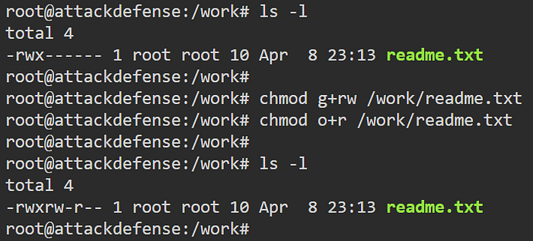

**Q 6. Change the permission set of /work/readme.txt so that only the user (owner) can read/write/ execute, group, and any user can execute it. However, whenever anyone executes it, it should run with the privileges of the group. Use absolute mode.**

Set the permission. To make sure it only executes with the group’s privileges, set setgid bit.

**Command:** chmod 2711 /work/readme.txt

Here, 2 is to setguid bit (4 can be used for setuid bit and 1 can be used for sticky bit)

7 is to set read/write/execute permissions for the owner

1 is to set execute permission for group

1 is to set execute permission for other users

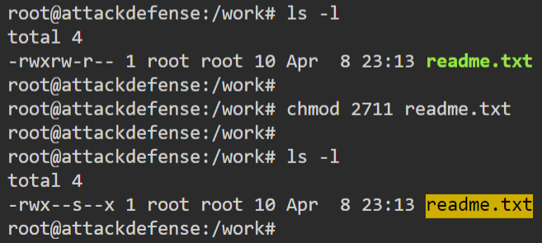

**Q 7. Change the permission set of /work/readme.txt so that only the owner can rename or delete this file while maintaining the existing permissions. Use absolute mode.**

Set sticky bit on the file

**Command:** chmod 3711 /work/readme.txt

